**Research Questions**

* What are the variables that affect hotel reservation cancellations?
* How can we make hotel reservation cancellations better?
* How will hotels be assisted in making pricing and promotional decisions?

**Hypothesis**

* More cancellations occur when prices are high.
* When there is a longer waiting list, customers tend to cancel more frequently.
* The majority of clients come from offline travel agents to make their reservations.

**Analysis and Findings**

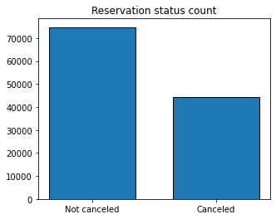

The accompanying bar graph shows the percentage of cancelled and non-cancelled reservations. It is obvious that there are still a significant number of reservations that have not been cancelled. There are still 37% of clients who cancel their reservations, which significantly impacts the hotel’s earnings.

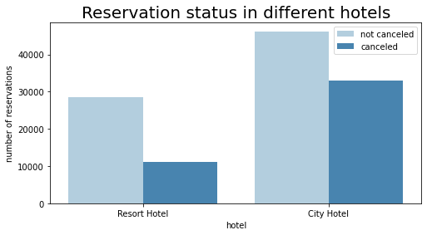

In comparison to resort hotels, city hotels have more bookings. It is possible that resort hotels are more expensive than those in cities.

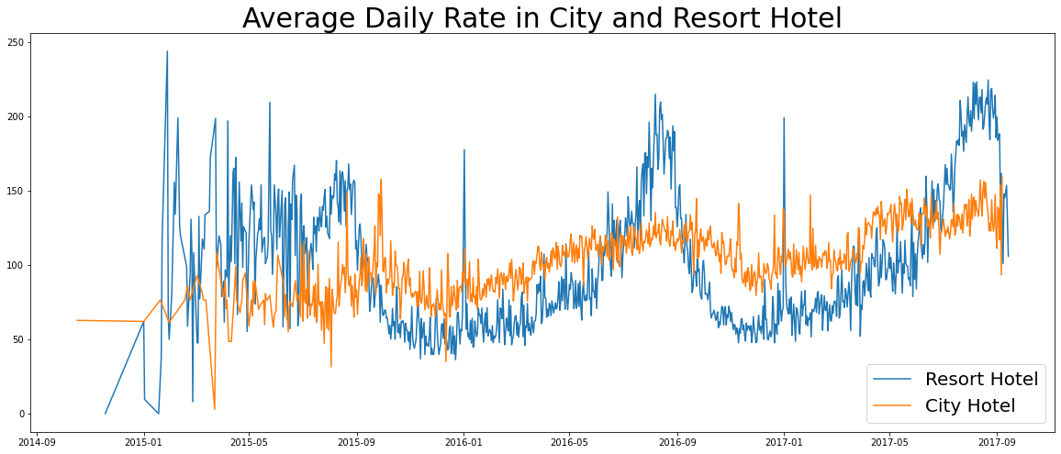

The line graph above shows that, on certain days, the average daily rate for a city hotel is less than that of a resort hotel, and on other days, it is even less. It goes without saying that weekends and holidays may see a rise in resort hotel rates.

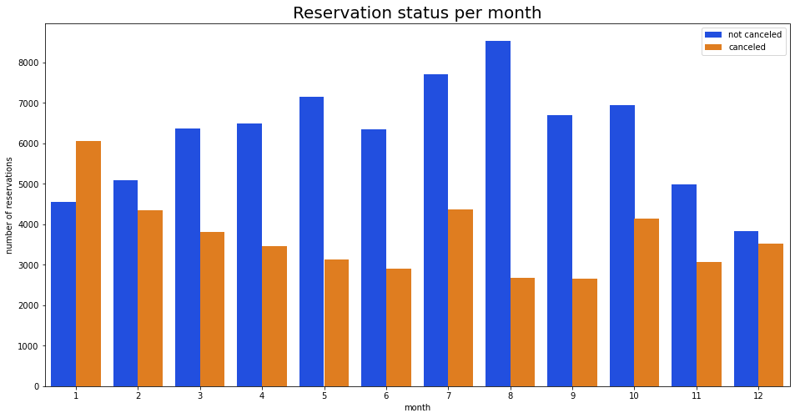

We have developed the grouped bar graph to analyze the months with the highest and lowest reservation levels according to reservation status. As can be seen, both the number of confirmed reservations and the number of cancelled reservations are the largest in the month of August. Whereas January is the month with the most cancelled reservations.

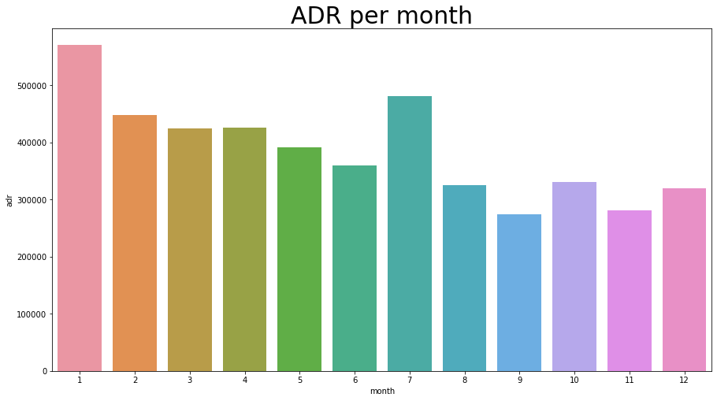

The bar graph demonstrates that cancellations are most common when prices are greatest and are least common when they are lowest. Therefore, the cost of the accommodation is solely responsible for the cancellation.

Now, let us see which country has the highest reservation cancellation rate. The graph shows that the top country is Portugal with the highest number of cancellations.

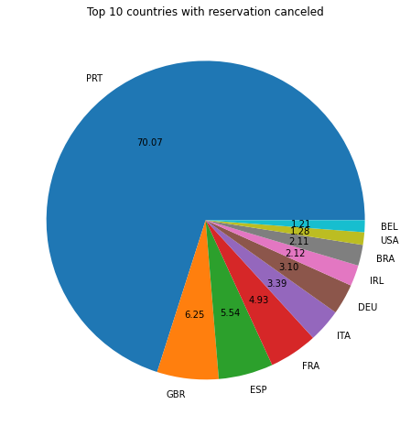

Let us check the area from where guests are visiting the hotels and making reservations. Is it coming from Direct or Groups, Online or Offline Travel Agents? Around 46% of the clients come from online travel agencies, whereas 27% come from groups. Only 4% of client’s book hotels directly by visiting them and making reservations.

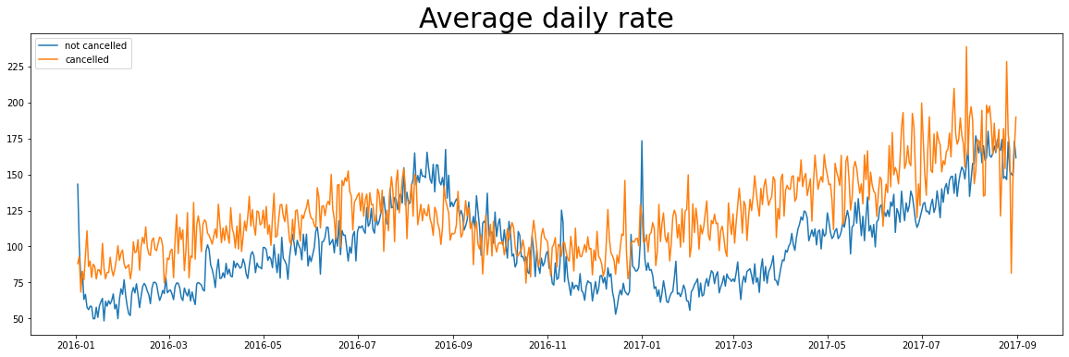

As seen in the graph, reservations are cancelled when the average daily rate is higher than when it is not cancelled. It clearly proves all the above analysis, that the higher price leads to a higher cancellations rate.

**Suggestions**

* Cancellation rates rise as the price does. In order to prevent cancellations of reservations, hotels could work on their pricing strategies and try to lower the rates for specific hotels based on locations, they can also provide some discounts to the consumers.
* As the ratio of the cancellation and non-cancellation of the resort hotel is higher in the resort hotel than the city hotels. The hotels should provide a reasonable discount on the room prices on weekends or on holidays.
* In the month of January, hotels can start campaigns or marketing with a reasonable amount to increase their revenue as the cancellation is the highest this month.
* They can also increase the quality if their hotels and their services mainly in Portugal to reduce the cancellation rate.